Excel Assignment-1

1. When we write anything or insert any data in an Excel sheet, we do it in a Cell.

A cell is named by combining the column and row intersecting each other. Columns are alphabetic and rows are numeric.

2. Follow these steps to lock cells in a worksheet:

1. Select the cells you want to lock.
2. On the Home tab, in the Alignment group, click the small arrow to open the Format Cells popup window.

3.On the Protection tab, select the Locked check box, and then click OK to close the popup.

3.

1. Right click on the worksheet tab and select Move or Copy.
2. Select the Create a copy checkbox.
3. UnderBefore sheet, select where you want to place the copy.
4. Select OK.

4.Key is used as a shortcut for opening a new window document is ctrl+N.

5. When we start a new Excel File, we can see the following Excel environment:

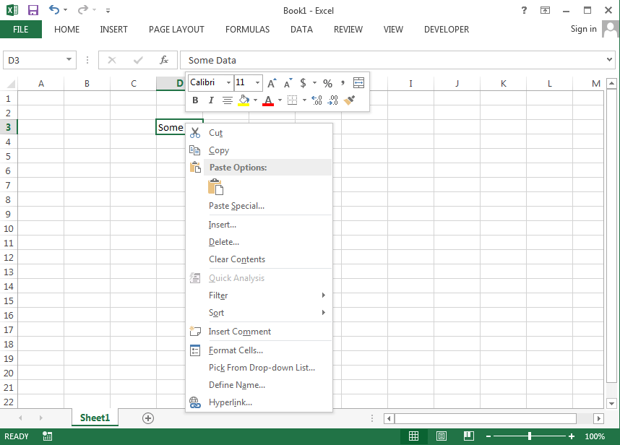

6.Relative cell references are used whenever calculations need to be repeated.

For instance, in cell A1, we have “=B1+C1.” On copying this formula to cell B2, the formula becomes “=C2+D2.” This is because the first formula refers to two cells on the right of cell A1 while the second formula refers to two cells on the right of cell B2. Cells B1 and C1 are to the right of cell A1 and cells C2 and D2 are to the right of cell B2.

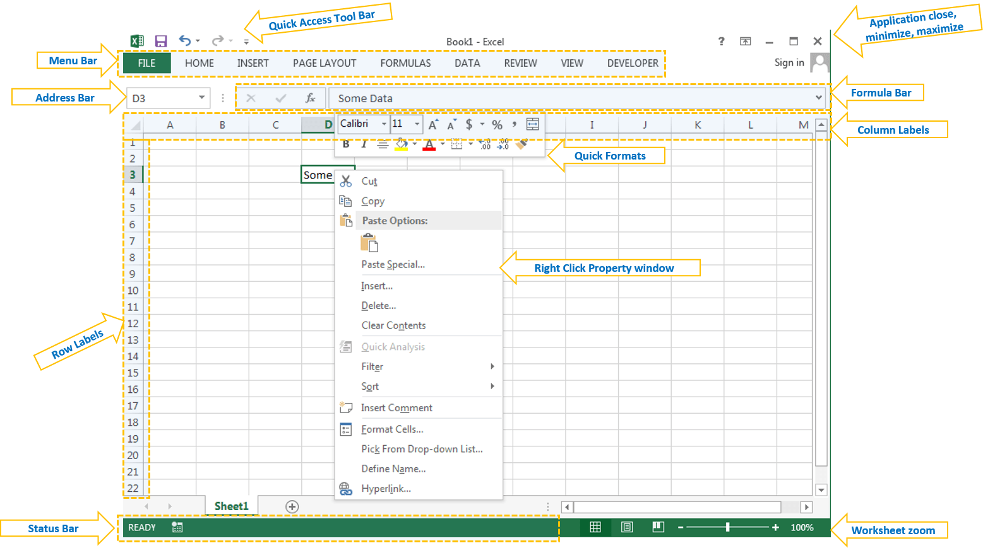

**Menu Bar or Ribbon:** Here you can find different verities of utilities to deal with Excel to do our jobs

**Address Bar:** We can see the active Cell, Range or Object Name here. You can type any name of the object to activate it

**Formula Bar:** We can write a formula in Cell or Object using Formula Bar

**Application or Windows Button:** We can use this to minimize, maximize or close the application

**Status Bar:** Where you can see the status of the Application task, we can print status using VBA

**Zoom:** We can increase or decrease the zoom levels of the worksheets

**Quick Access Tool Bar:** We can assign any utility to quickly access it.

Excel Objects are explained here

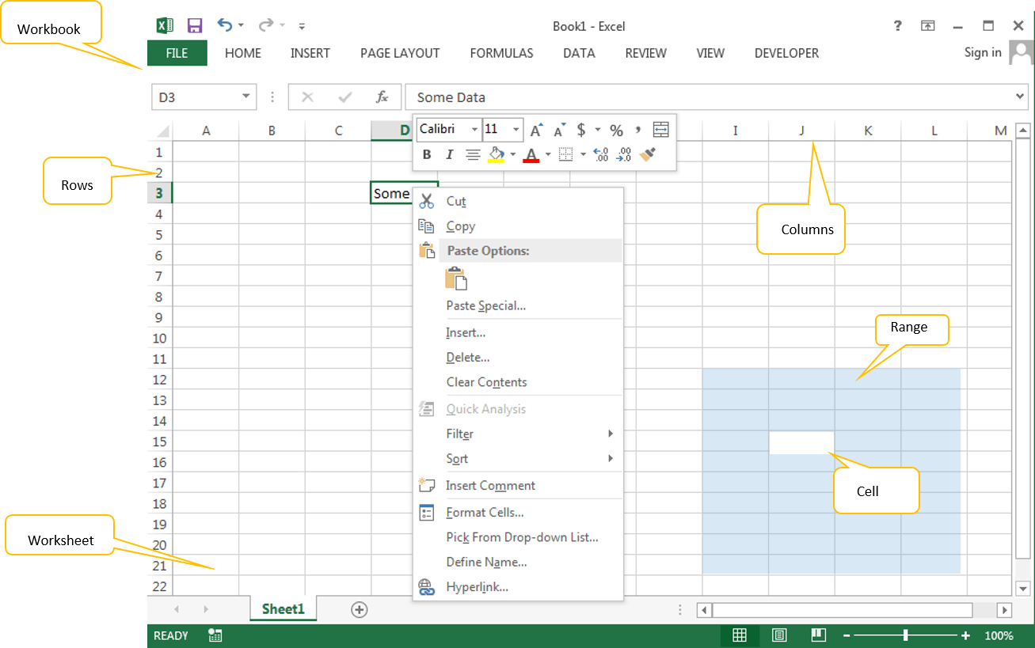

**Workbook:** It is the main file, which we can give name and store it in desired folder. All other objects are part of this workkbook

**Worksheet:** It is a the space where we can enter our data and format. A workbook is a collection of worksheets

**Cell:** Cell is the part of the worksheet, where we enter the data, formulas.

**Range:** It is a collection of Cells in excel worksheet.

**Rows:** These are records (1,2,3,4…) in excel worksheet.

**Columns:** These are Fields (A,B,C,D,…) in excel worksheet.